Decolonized History
The purpose of Decolonized History is to present History that is not taught in school in an accurate and understandable way.
History is nuanced, needlessly complicated, where complex ideas are dumbed-down, while stupid ideas become so bickered over that you’d have to be masochistic to approach History with honesty.
Meanwhile History is just the broad study of change over time.
And this change over time is told through different forms of storytelling.
When we refer to decolonizing History we are simply talking honestly about the study of change over time.

What Does Decolonization Mean?
"Decolonization is the dismantling of the process by which one nation asserts and establishes its domination and control over another nation’s land, people and culture"
- British Colombia's Office of the Human Rights Commissioner
Which means are only hope is cutting the crap, and the first step of doing that is understanding that...
No clear and unequivocal evidence of racism has been found in other cultures or in Europe before the Middle Ages.
George M. Fredrickson
Race: A Profitable Myth - To learn why "Race" was conceptualized in the 18th century, Click Here
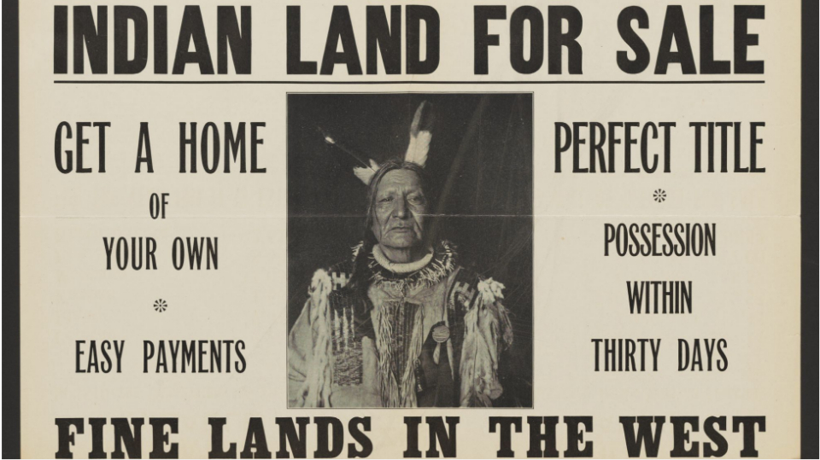A poster advertises an upcoming sale of stolen Indigenous land by the United States Department of the Interior in 1911. | Library of Congress (used to be)
The art of storytelling and learning history are the same, the only difference is the shifting of the cultural lens

Monsheeda (Dust Maker), and his wife Mehunga (Standing Buffalo), of the Ponca tribe, posed together in their wedding photo, circa 1900 (1850-1925)

HISTORY
History is a lesson into the complexities of the human mind in both beauty and horror.
So let us guide you into the complex ideas of history that continue to affect us to this day, so hopefully we can learn how to create a better tomorrow.

Starter Links:
Cultural Directory
World History
World Stories

Current Projects
The Undead: A Buried History
The Original Peoples History: Australia

